# Naan Mudhalvan

**DIGITAL MARKETING**

**FINAL PROJECT TITLE:**

HOW TO CREATE A REEL DESIGN USING CANVA

**COLLEGE NAME:**

CHENDHURAN COLLEGE OF ENGINEERING AND TECHNOLOGY

**DEPARTMENT:**

MECHANICAL ENGINEERING

**YEAR/SEM:**

FINAL YEAR/ 7TH SEM

**TEAM MEMBERS:**(4 PERSON)

|  |  |  |  |
| --- | --- | --- | --- |
| **S.NO** | **NAME** | **NAAN MUDHALVAN ID** | **REGISTER NUMBER** |
| 1 | C. VIGNESH - **(LEDER)** | 8D6A97B32191496BECE4F341F46CA3E7 | (910320114313) |
| 2 | B. MOHAMMED IBRAHIM | 3DB7C4EB846CB49ADAD4F00E95AB0734 | (910320114309) |
| 3 | T. KAVINAKASH | DCE84FE672AAC69AB1D4FB5C38566637 | (910320114307) |
| 4 | T. MANIKANDAN | D2AB12DD94E7E9F8D424AE527C64862B | (910320114308) |

Reels upload link:

<https://www.canva.com/design/DAFyV9DrKVo/95cbFbgmfwkHiUydW5CqBg/watch?utm_content=DAFyV9DrKVo&utm_campaign=designshare&utm_medium=link&utm_source=editor>

Canva video link:

https://www.canva.com/design/DAFyV9DrKVo/watch

Instagram reels link:

https://www.instagram.com/reel/Cy26FcWhqHd/?utm_source=ig_web_copy_link&igshid=MzRlODBiNWFlZA==

PROJECT SCREEN SHOTS

create a new design and search for instagram reels screenshot

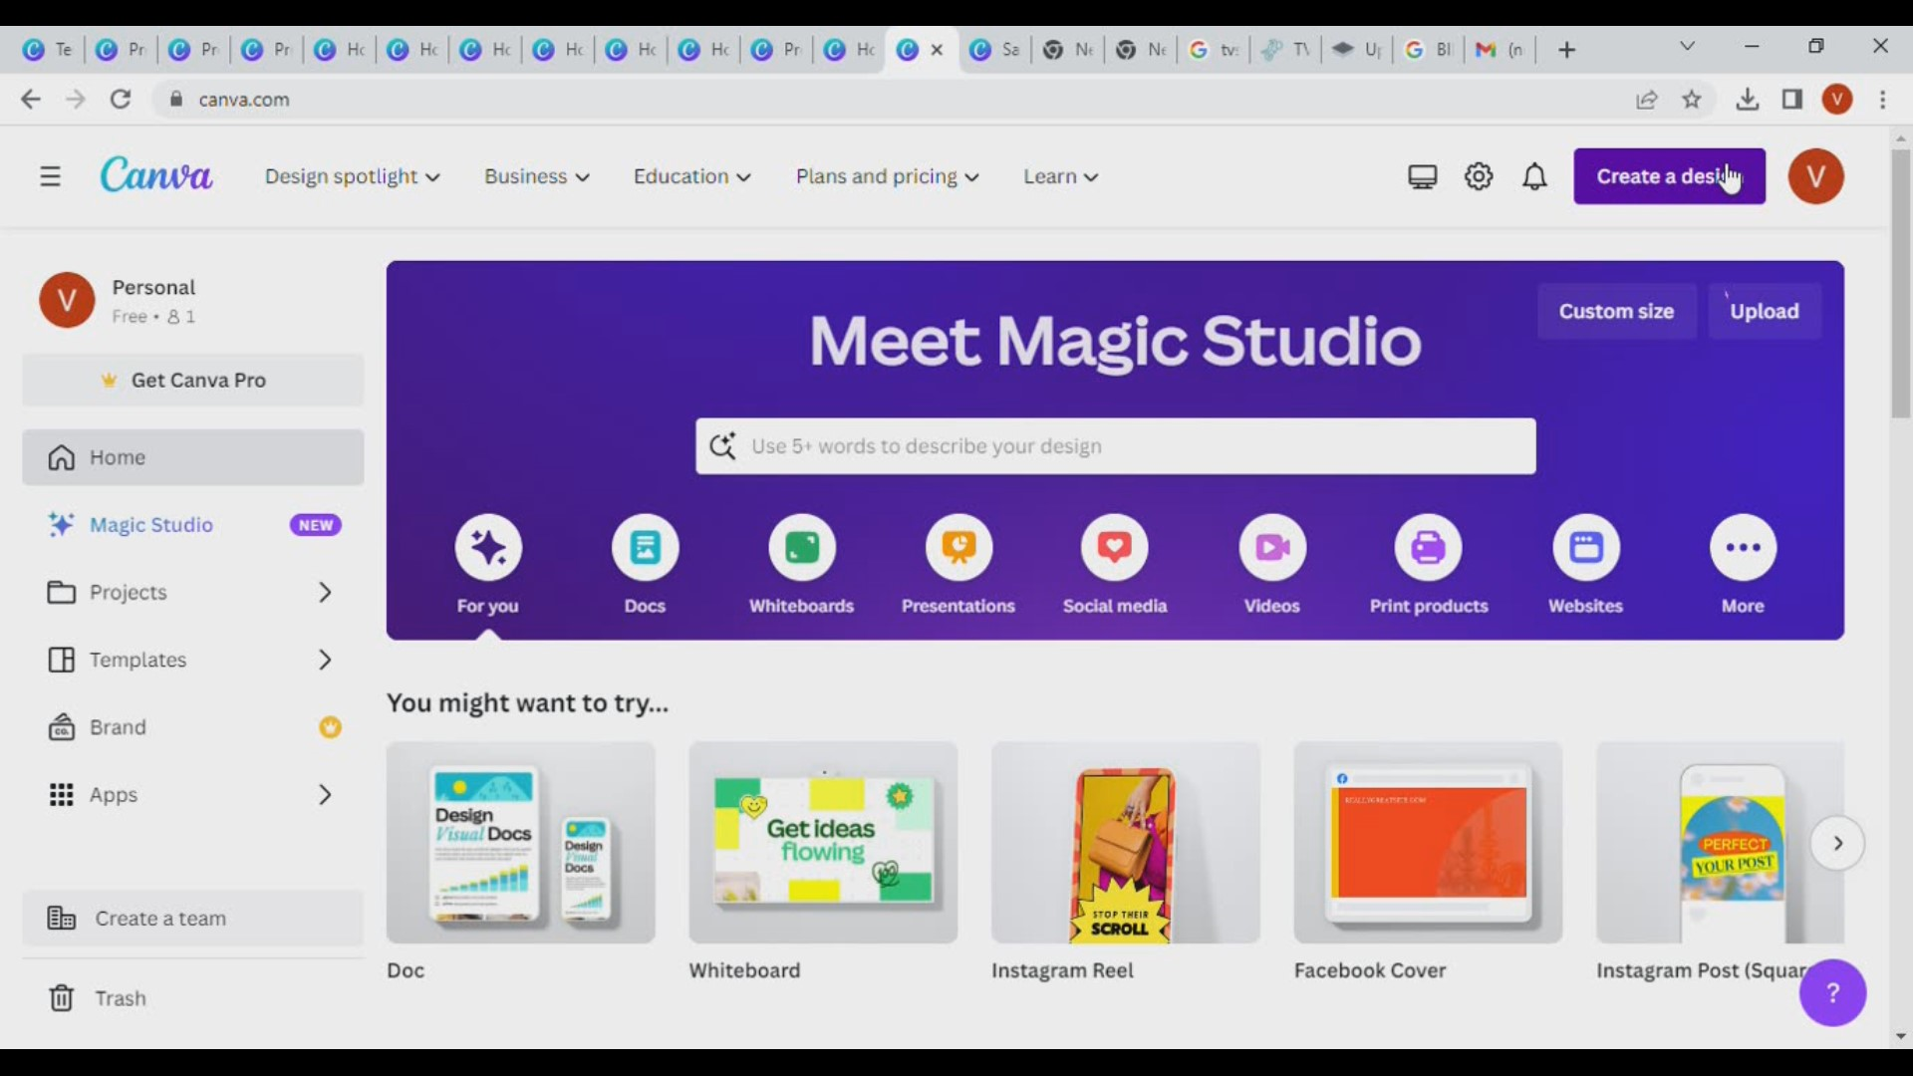

Add image grapics text video clip

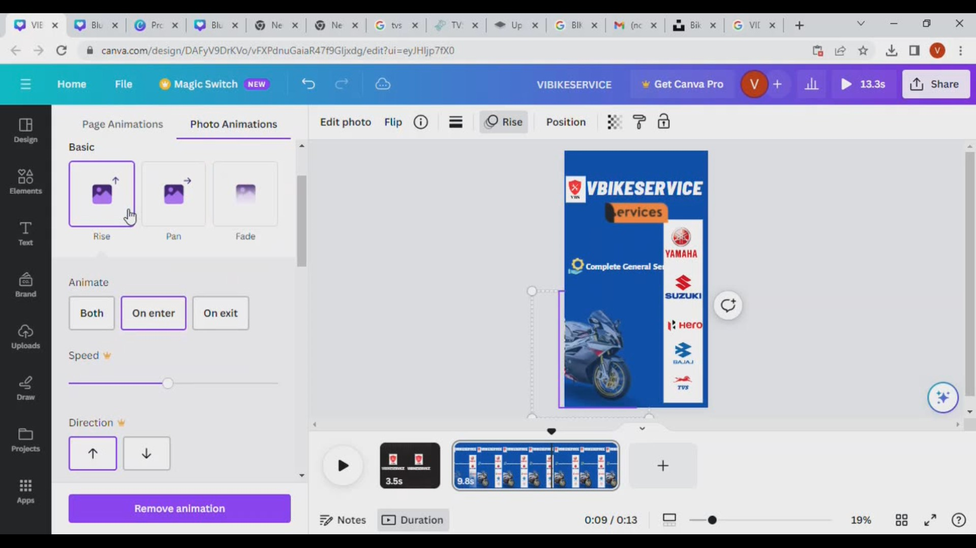

Instagram page open screenshot

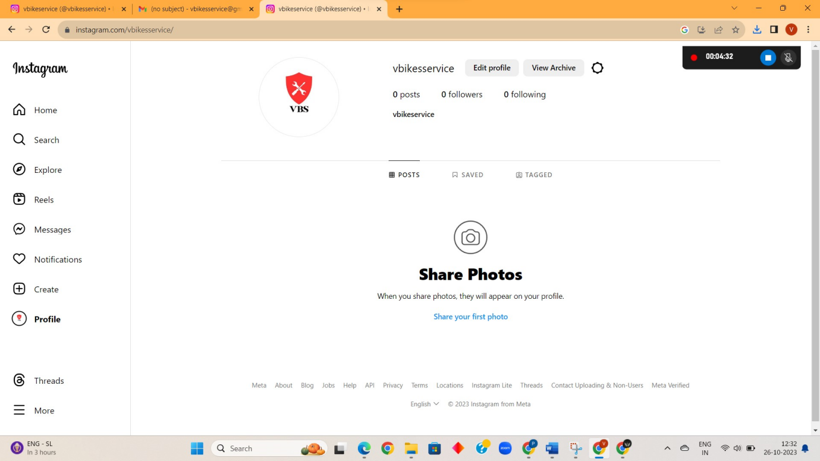

Reels upload screenshot

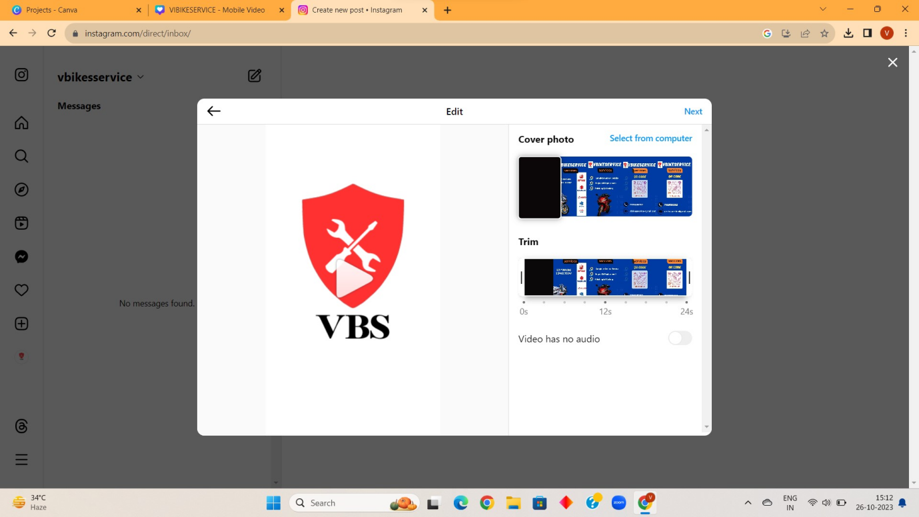

Instagram reels description create screenshot

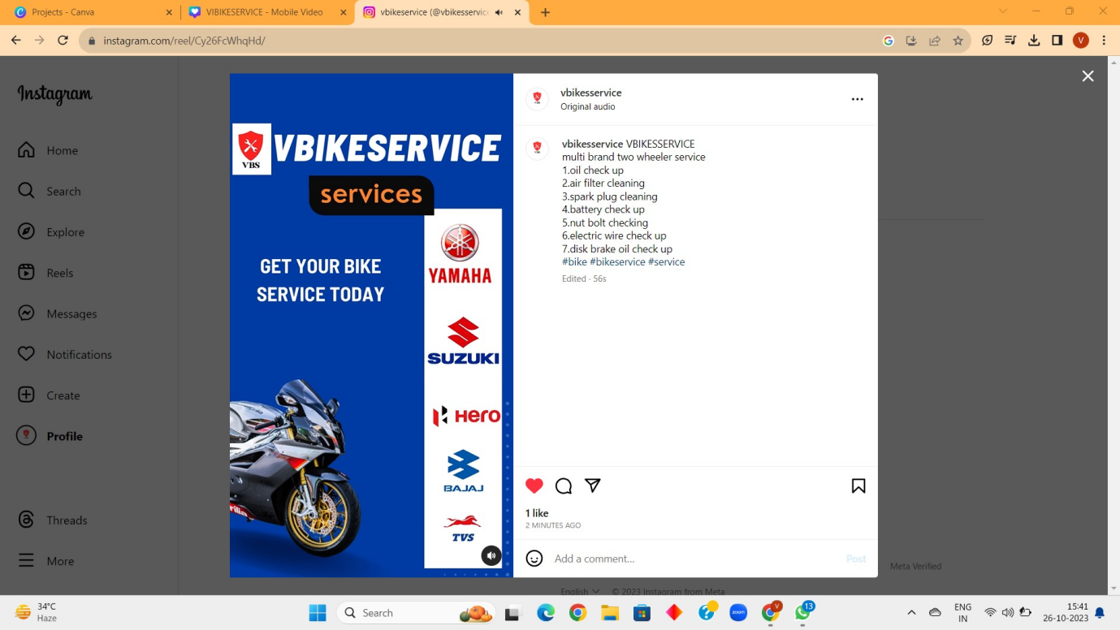

Instagram reels published

